Operating instructions v1.00 Brantz Marshalling Clock (BR42)

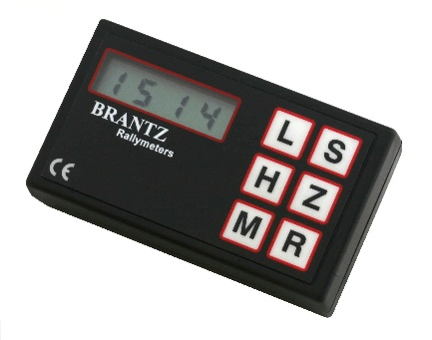
Overview

The Marshalling Clock features Hours, Minutes, Seconds and Hundreds of a Second. Its primary function is to hold the time of day for logging purposes when a competitor completes a stage of the competition, then restore the current time of day after the competitors time has been recorded.

Features:
- Displays HH:MM:SS:MSMS spread over two 4 digit LCD Screens
- Back-Light Button
  - Factory Modification available – External Switch for Permanent Light ON or OFF
- Memory of last stored Time
- Powered via 9V Battery

Marshalling Clock Use:

- To initialize the Marshalling clock;
  - When you first switch on the unit, the words 'not Set' appear on the screen.
  - Hold down the H Button and momentarily press the M Button, then release the H button to set the time (Hours:Minutes) in 24Hr format.
  - The H Button will swap between the pairs of digits.
  - The R Button will swap screens showing (Hours : Minutes) or (Seconds . Hundredths of a Second) – The difference can be determined by the colon vs single decimal place. This works in both the setting mode and standard mode.
  - The flashing pair of digits can be incremented by repeated pressing of the S Button, or can be zeroed with the Z Button.
  - When the time has been set hold down the H Button and momentarily press the R Button, then release the H Button to exit the setting mode. To prevent the time being inadvertently altered in the field; once the time setting mode has been exited, it cannot be reset unless the whole clock is powered down for a few seconds.
- The R Button toggles between (Hours : Minutes) and (Seconds . Hundredths of a Second) being displayed. The Marshal can use this button at any time without affecting anything else.
- Press the S Button when the competitor enters the timed point. This freezes the screen with competitors’ time and also puts this into the memory, replacing any previously remembered time. Pressing the R button at this point will display the whole of the frozen time alternating between Hr:Mins or Secs.HundS.
- Pressing the Z Button restores the screen to the present time of day.
- Pressing the M Button will recall the last remembered time to the screen and again Z will restore the current time.

Factory Modifications:

These modifications are available from Brantz either as a Special Pre-Order request as an after-market, Retro-fit.
- External Power ON/OFF Switch – 1 slide switch
- External Light Continuous ON/OFF Switch – 1 slide switch
- External Power & Continuous Light ON/OFF Switch – 1 slide switch
- External Power & External Light ON/OFF Switch – 2 slide switches

For more information on these modifications or any other questions you have regarding Brantz Products – Please phone: 0044 (0) 1625 669366 or email: sales@brantz.co.uk
phone: 0044 (0) 1625 669366 or email: sales@brantz.co.uk

